**Team #<*20*>**

|  |  |  |
| --- | --- | --- |
| **Team Member Name** | **PID** | **UCSD Email ID** |
| Darell Hoei | A14204862 | dhoei@ucsd.edu |
| Christhoper Bernard | A14211658 | chbernar@ucsd.edu |
| Alan Bui | A12909805 | apb004@ucsd.edu |
| Muyun Liu | A53238751 | mul046@ucsd.edu |
| Alice Yu | A92142818 | jiy236@ucsd.edu |
| Ibtehal Rizzo | A13344613 | irizzo@ucsd.edu |

**Milestone 1 - Delivery Phase**

**Software design**

Repository Link: <https://github.com/CSE-110-Winter-2018/cse-110-team-project-team-20/tree/milestone1_delivery>

3 Example Methods ( DRY):

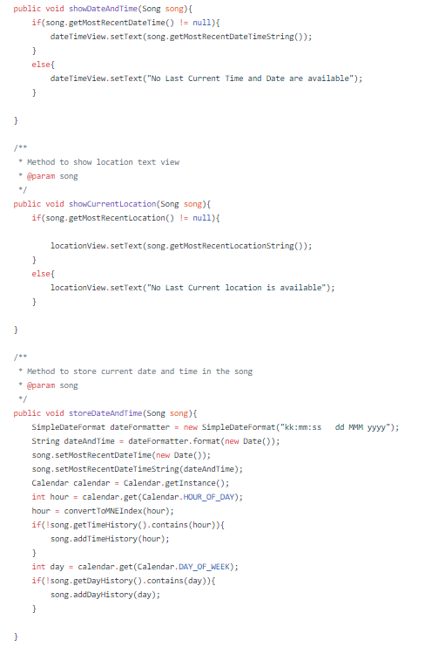

With usage of

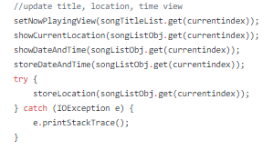

Example of SRP:

<https://github.com/CSE-110-Winter-2018/cse-110-team-project-team-20/blob/milestone1_delivery/app/src/main/java/team20/flashbackmusic/Song.java>

**Testing**

Link(s) to all the JUnit and/or Espresso tests and logs of untestable non-trivial methods.

Something like this:

https://github.com/CSE-110-Winter-2018/Default-Repository/blob/milestone1_delivery/MyApplication/app/src/main/jav a/com/andriod/helloworld/MainActivity.java#L23-L27

Notice how specific line numbers in the concerned source code file have been mentioned in the URL above.

Junit test for sorter() function in Playlist_flashback class

<https://github.com/CSE-110-Winter-2018/cse-110-team-project-team-20/blob/milestone1_delivery/app/src/androidTest/java/team20/flashbackmusic/test_flashback.java>

Junit test for score() function in Score class

[https://github.com/CSE-110-Winter-2018/cse-110-team-project-team-20/blob/milestone1_delivery/app/src/androidTest/java/team20/flashbackmusic/testforscore.java](https://github.com/CSE-110-Winter-2018/cse-110-team-project-team-20/blob/milestone1/app/src/androidTest/java/team20/flashbackmusic/testforscore.java)

Junit for Song class

<https://github.com/CSE-110-Winter-2018/cse-110-team-project-team-20/blob/milestone1_delivery/app/src/androidTest/java/team20/flashbackmusic/SongClassTest.java>

Junit for Album Class

<https://github.com/CSE-110-Winter-2018/cse-110-team-project-team-20/blob/milestone1_delivery/app/src/androidTest/java/team20/flashbackmusic/AlbumClassTest.java>

Junit test for getting address

<https://github.com/CSE-110-Winter-2018/cse-110-team-project-team-20/blob/milestone1_delivery/app/src/androidTest/java/team20/flashbackmusic/GetAddressTest.java>

Espresso for play album

<https://github.com/CSE-110-Winter-2018/cse-110-team-project-team-20/blob/milestone1_delivery/app/src/androidTest/java/team20/flashbackmusic/PlayAlbumEspressoTest.java>

Espresso

<https://github.com/CSE-110-Winter-2018/cse-110-team-project-team-20/blob/milestone1_delivery/app/src/androidTest/java/team20/flashbackmusic/PlayPauseBackForwardNormalModeEspresso.java>

Non-trivial methods links:

<https://github.com/CSE-110-Winter-2018/cse-110-team-project-team-20/blob/milestone1_delivery/app/src/main/java/team20/flashbackmusic/MainActivity.java#L187-L233>

<https://github.com/CSE-110-Winter-2018/cse-110-team-project-team-20/blob/milestone1_delivery/app/src/main/java/team20/flashbackmusic/MainActivity.java#L414-L463>

<https://github.com/CSE-110-Winter-2018/cse-110-team-project-team-20/blob/milestone1_delivery/app/src/main/java/team20/flashbackmusic/MainActivity.java#L467-L482>

<https://github.com/CSE-110-Winter-2018/cse-110-team-project-team-20/blob/milestone1_delivery/app/src/main/java/team20/flashbackmusic/MainActivity.java#L486-L509>

<https://github.com/CSE-110-Winter-2018/cse-110-team-project-team-20/blob/milestone1_delivery/app/src/main/java/team20/flashbackmusic/MainActivity.java#L518-L551>

<https://github.com/CSE-110-Winter-2018/cse-110-team-project-team-20/blob/milestone1_delivery/app/src/main/java/team20/flashbackmusic/MainActivity.java#L555-L585>

<https://github.com/CSE-110-Winter-2018/cse-110-team-project-team-20/blob/4594c118b147e9d47c985345a14c68a147cc1b57/app/src/main/java/team20/flashbackmusic/MainActivity.java#L596-L634>

[https://github.com/CSE-110-Winter-2018/cse-110-team-project-team-20/blob/4594c118b147e9d47c985345a14c68a147cc1b57/app/src/main/java/team20/flashbackmusic/MainActivity.java#L640-L661](https://github.com/CSE-110-Winter-2018/cse-110-team-project-team-20/blob/4594c118b147e9d47c985345a14c68a147cc1b57/app/src/main/java/team20/flashbackmusic/MainActivity.java#L640-661)

[https://github.com/CSE-110-Winter-2018/cse-110-team-project-team-20/blob/4594c118b147e9d47c985345a14c68a147cc1b57/app/src/main/java/team20/flashbackmusic/MainActivity.java#L706-L765](https://github.com/CSE-110-Winter-2018/cse-110-team-project-team-20/blob/4594c118b147e9d47c985345a14c68a147cc1b57/app/src/main/java/team20/flashbackmusic/MainActivity.java#L706-765)

<https://github.com/CSE-110-Winter-2018/cse-110-team-project-team-20/blob/4594c118b147e9d47c985345a14c68a147cc1b57/app/src/main/java/team20/flashbackmusic/MainActivity.java#L847-L876>

<https://github.com/CSE-110-Winter-2018/cse-110-team-project-team-20/blob/4594c118b147e9d47c985345a14c68a147cc1b57/app/src/main/java/team20/flashbackmusic/MainActivity.java#L883-L969>

<https://github.com/CSE-110-Winter-2018/cse-110-team-project-team-20/blob/4594c118b147e9d47c985345a14c68a147cc1b57/app/src/main/java/team20/flashbackmusic/MainActivity.java#L975-L1035>

**ZenHub**

1. Zenhub Board Link:

<https://app.zenhub.com/workspace/o/cse-110-winter-2018/cse-110-team-project-team-20/boards?repos=119332515>

2. Burndown Chart Link:

<https://app.zenhub.com/workspace/o/cse-110-winter-2018/cse-110-team-project-team-20/reports?report=burndown&milestoneId=3076847&showPRs=false>

**GitHub**

1.

We have several branches for our contribution and in the chart it is not showing all contributions, so we came up with branch link just in case:

Note:

We did pair-programming (Christhoper-Darell, Alan-Muyun, Alice-Ibtehal)

<https://github.com/CSE-110-Winter-2018/cse-110-team-project-team-20/branches>

<https://github.com/CSE-110-Winter-2018/cse-110-team-project-team-20/graphs/contributors>

2.

milestone1_delivery link:

<https://github.com/CSE-110-Winter-2018/cse-110-team-project-team-20/tree/milestone1_delivery>